Chapter 14.11 Lab: Installing and Updating Software Packages

Marko Shaffer

Information Technology, Franklin University

ITEC 200: Linux Fundamentals

Professor Kagan Ulucay

7/2/2023

**Red Hat System Administration I 8.2**

**Lab 10 CH 14.11 Installing and Updating Software Packages**

# ****Performance Checklist****

**In this lab, you will set up key-based authentication for users, and disable direct login as root and password authentication for all users for the OpenSSH service on one of your servers.**

# ****Outcomes****

**You should be able to:**

* **Authenticate using SSH keys.**
* **Prevent users from directly logging in as root over ssh.**
* **Prevent users from logging in to the system using SSH password-based authentication.**

# ****Log in to workstation as student using student as the password.****

|  |  |  |  |
| --- | --- | --- | --- |
|  | Franklin VM: | Standard User Account: | The Student's Root Account: |
| Username | kiosk | student | root |
| Password | redhat | student | redhat |

<https://franklin.instructure.com/courses/12488/modules/items/683350>

[kiosk@foundation0 ~]$ rht-vmctl start all

[kiosk@foundation0 ~]$ rht-vmview view workstation

# ****Start Lab****

On workstation, run the **lab software-review start** command. This script ensures that serverb is available. It also downloads any packages required for the lab exercise.

**[student@workstation ~]$ lab software-review start**

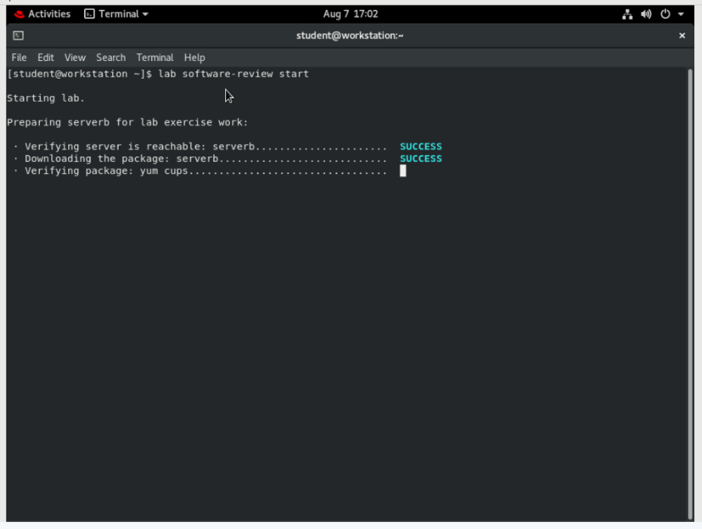

1. On serverb configure a software repository to obtain updates. Name the repository as errata and configure the repository in the /etc/yum.repos.d/errata.repo file. It should access

 http://content.example.com/rhel8.2/x86_64/rhcsa-practice/errata. Do not check GPG signatures.

* 1. From workstation use the **ssh** command to log in to serverb as the student user.

**[student@workstation ~]$ ssh student@serverb**

*...output omitted...*

[student@serverb ~]$

* 1. Use the sudo -i command to switch to the root user.

**[student@serverb ~]$ sudo -i**

[sudo] password for student: **student**

[root@serverb ~]#

* 1. Create the file /etc/yum.repos.d/errata.repo with the following content:

[errata]

name=Red Hat Updates

baseurl=http://content.example.com/rhel8.2/x86_64/rhcsa-practice/errata

enabled=1

gpgcheck=0

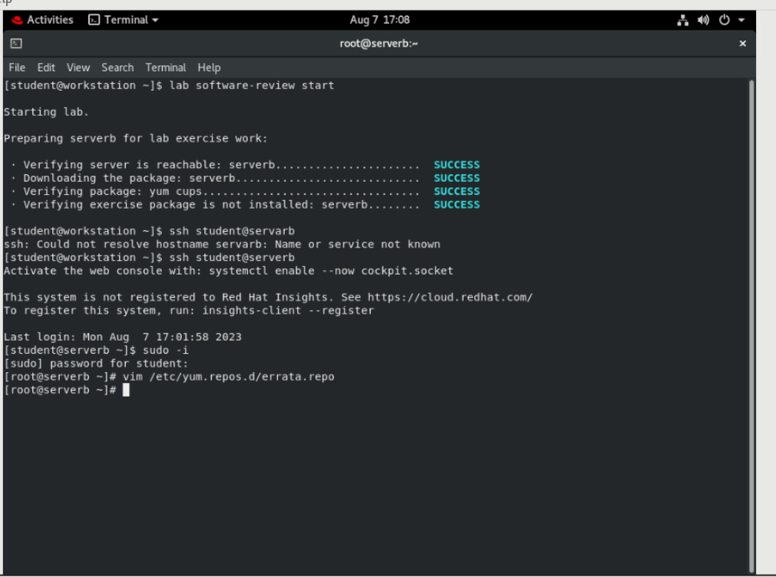

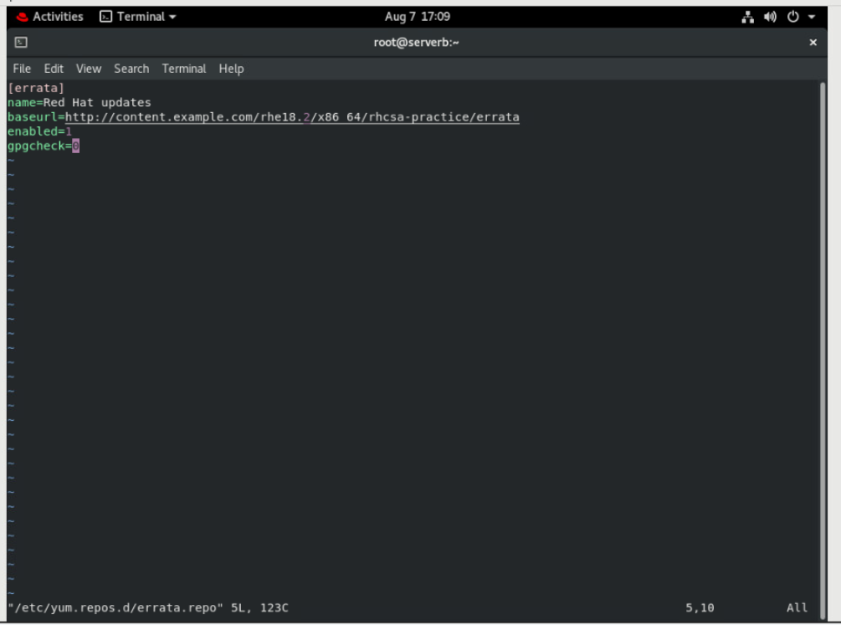

1. On serverb, install new package xsane-gimp and the Apache HTTP Server module from the 2.4 stream and the common profile.
   1. Use the yum list command to list the available packages for xsane-gimp.

**[root@serverb ~]# yum list xsane-gimp**

Last metadata expiration check: 0:24:30 ago on Thu 07 Mar 2019 03:50:55 PM CET.

**Available Packages**

**xsane-gimp.x86_64** 0.999-30.el8 rhel-8.2-for-x86_64-appstream-rpms

* 1. Install the latest version of the xsane-gimp package using the yum install command.

**[root@serverb ~]# yum install xsane-gimp**

*...output omitted...*

Install 59 Packages

Total download size: 53 M

Installed size: 217 M

Is this ok [y/N]: **y**

*...output omitted...*

Complete!

[root@serverb ~]#

* 1. List available modules and streams. Look for the httpd module. Use the yum install command to install the httpd module with the 2.4 stream and the common profile.

**[student@serverb ~]$ yum module list**

Name Stream Profiles Summary

*...output omitted...*

httpd 2.4 [d] common [d], devel, minimal Apache HTTP Server

*...output omitted...*

**[root@serverb ~]# yum module install httpd:2.4/common**

Install 10 Packages

Total download size: 2.1 M

Installed size: 5.7 M

Is this ok [y/N]: **y**

*...output omitted...*

Complete!

[root@serverb ~]#

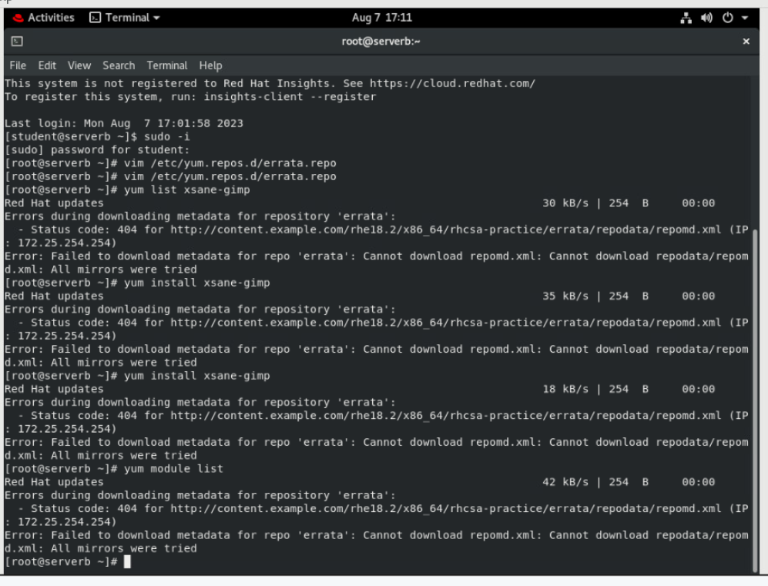

1. For security reasons, serverb should not be able to send anything to print. Achieve this by removing the cups package. Exit from the root account.
   1. Use the yum list command to list the installed cups package.

**[root@serverb ~]# yum list cups**

Installed Packages

**cups.x86_64** 1:2.2.6-33.el8 @rhel-8.2-for-x86_64-appstream-rpms

[root@serverb ~]#

* 1. Use the yum remove command to remove the cups package.

**[root@serverb ~]# yum remove cups.x86_64**

*...output omitted...*

Remove 9 Packages

Freed space: 11 M

Is this ok [y/N]: **y**

*...output omitted...*

Complete!

* 1. Exit from the root account.

**[root@serverb ~]# exit**

[student@serverb ~]$

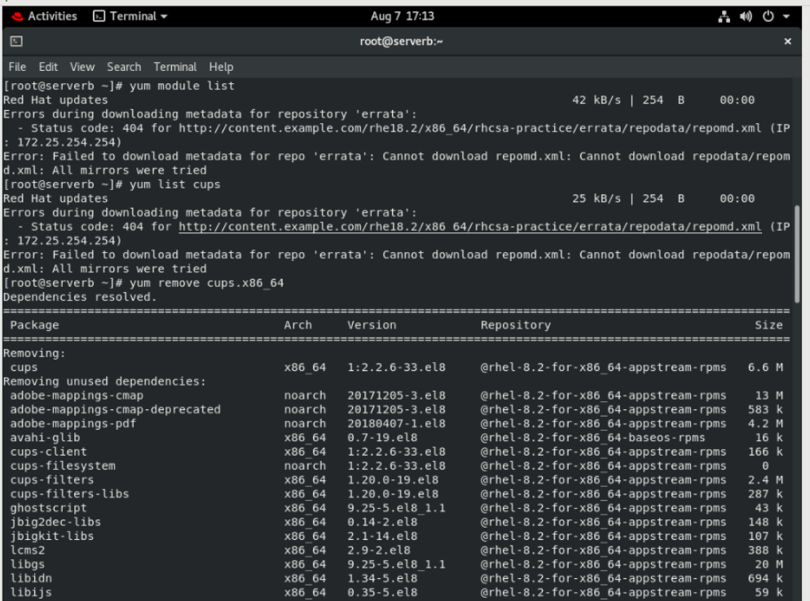

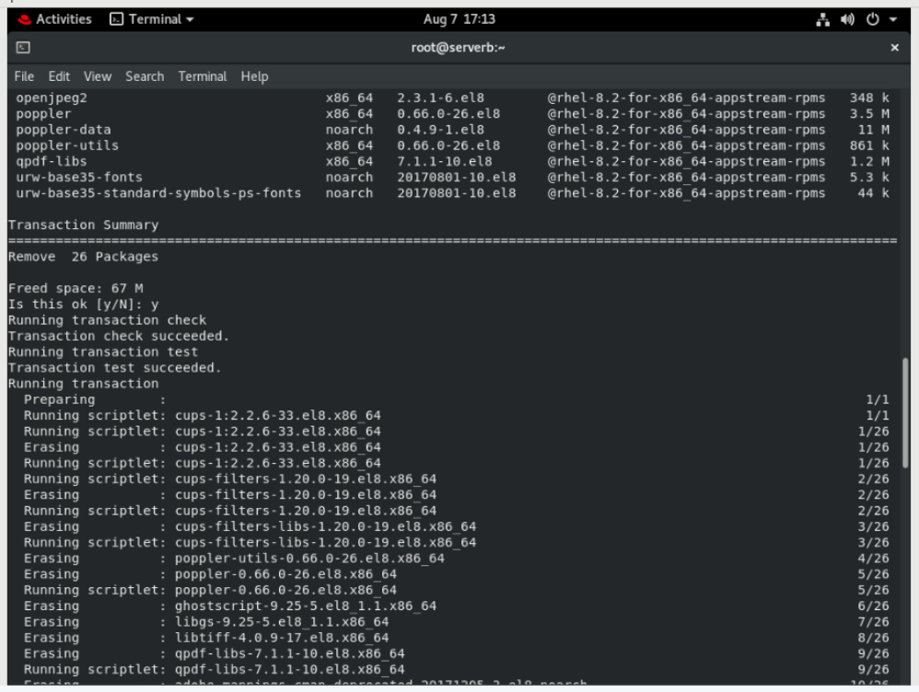

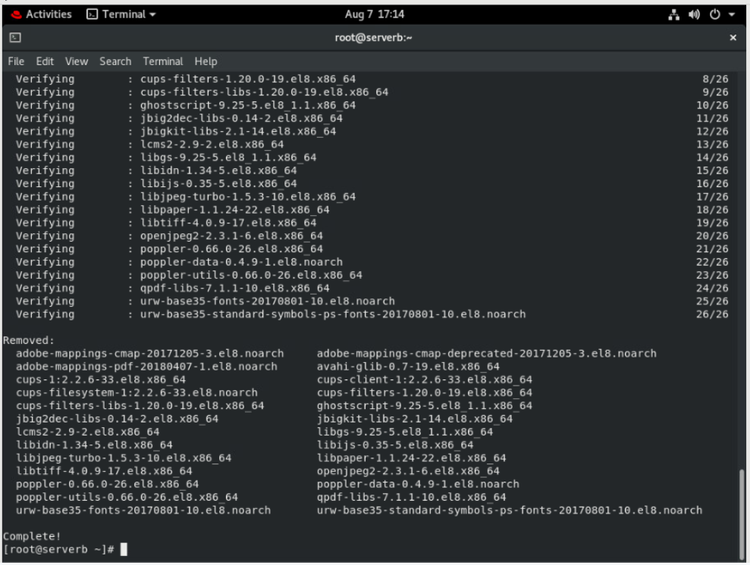

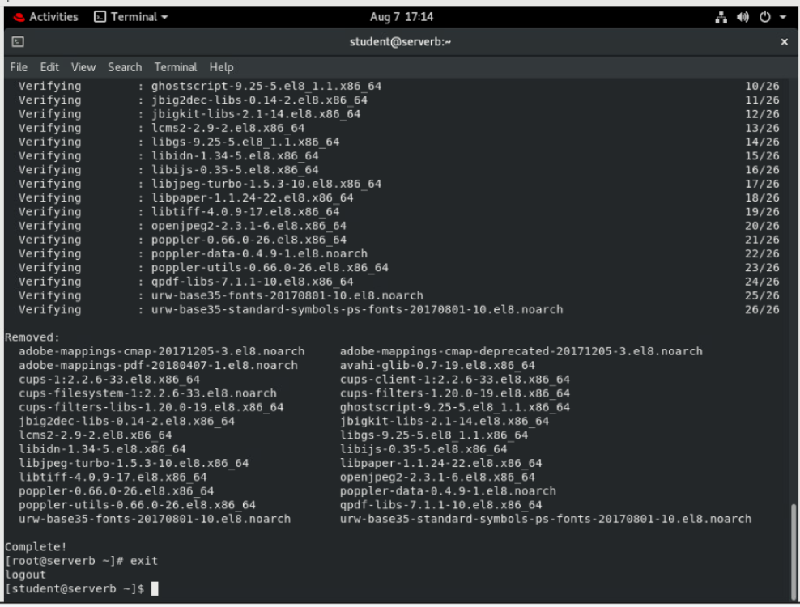

1. The start script downloads the rhcsa-script-1.0.0-1.noarch.rpm package in the /home/student directory on serverb.

Confirm that the package rhcsa-script-1.0.0-1.noarch.rpm is available on serverb. Install the package. You will need to gain superuser privileges to install the package. Verify that the package is installed. Exit from serverb.

* 1. Use the rpm command to confirm that the rhcsa-script-1.0.0-1.noarch.rpm package is available on serverb by viewing the package information.

**[student@serverb ~]$ rpm -q -p rhcsa-script-1.0.0-1.noarch.rpm -i**

Name : rhcsa-script

Version : 1.0.0

Release : 1

Architecture: noarch

Install Date: (not installed)

Group : System

Size : 1056

License : GPL

Signature : (none)

Source RPM : rhcsa-script-1.0.0-1.src.rpm

Build Date : Wed 06 Mar 2019 11:29:46 AM CET

Build Host : foundation0.ilt.example.com

Relocations : (not relocatable)

Packager : Snehangshu Karmakar

URL : http://example.com

Summary : RHCSA Practice Script

Description :

A RHCSA practice script.

The package changes the motd.

* 1. Use the sudo yum localinstall command to install the rhcsa-script-1.0.0-1.noarch.rpm package. The password is student.

**[student@serverb ~]$ sudo yum localinstall \**

**rhcsa-script-1.0.0-1.noarch.rpm**

[sudo] password for student: **student**

Last metadata expiration check: 1:31:22 ago on Thu 07 Mar 2019 03:50:55 PM CET.

Dependencies resolved.

===================================================================

Package Arch Version Repository Size

===================================================================

Installing:

rhcsa-script noarch 1.0.0-1 @commandline 7.6 k

Transaction Summary

===================================================================

Install 1 Package

Total size: 7.6 k

Installed size: 1.0 k

Is this ok [y/N]: **y**

Downloading Packages:

Running transaction check

Transaction check succeeded.

Running transaction test

Transaction test succeeded.

Running transaction

Preparing : 1/1

Running scriptlet: rhcsa-script-1.0.0-1.noarch 1/1

Installing : rhcsa-script-1.0.0-1.noarch 1/1

Running scriptlet: rhcsa-script-1.0.0-1.noarch 1/1

Verifying : rhcsa-script-1.0.0-1.noarch 1/1

Installed:

rhcsa-script-1.0.0-1.noarch

Complete!

* 1. Use the rpm command to verify that the package is installed.

**[student@serverb ~]$ rpm -q rhcsa-script**

rhcsa-script-1.0.0-1.noarch

[student@serverb ~]$

* 1. Exit from serverb

**[student@serverb ~]$ exit**

logout

Connection to serverb closed.

[student@workstation ~]$

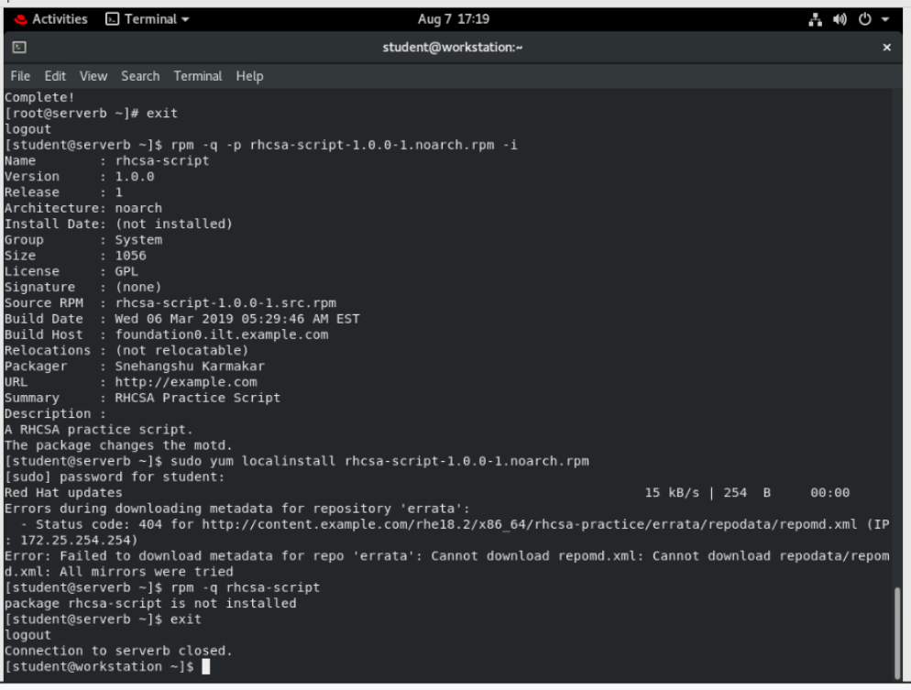

# Evaluation

On workstation, run the **lab software-review grade** script to confirm success on this lab.

**[student@workstation ~]$ lab software-review grade**

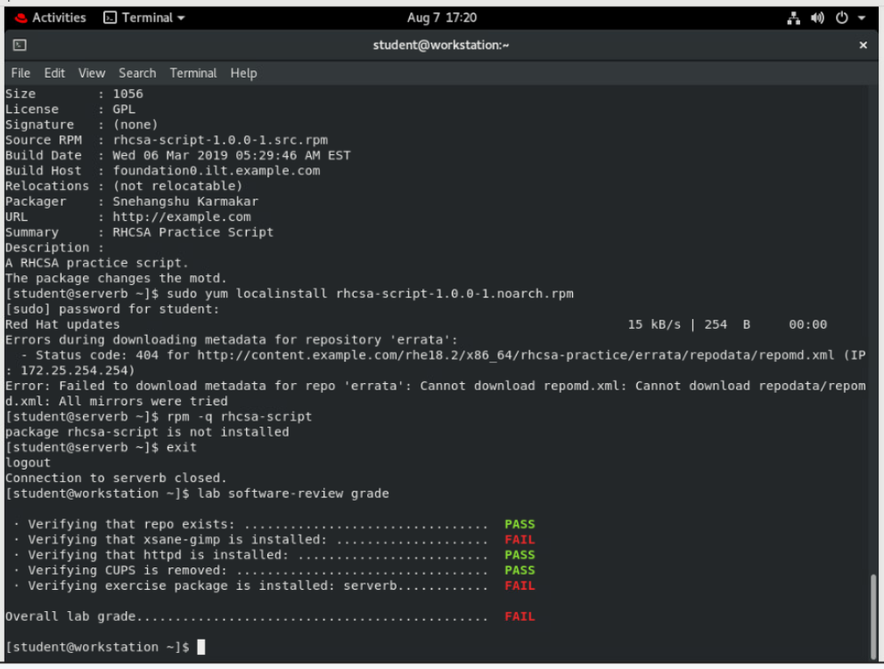

# Finish

On workstation, run the lab software-review finish script to complete this exercise. This script removes the repository and packages created during this exercise.

**[student@workstation ~]$ lab software-review finish**

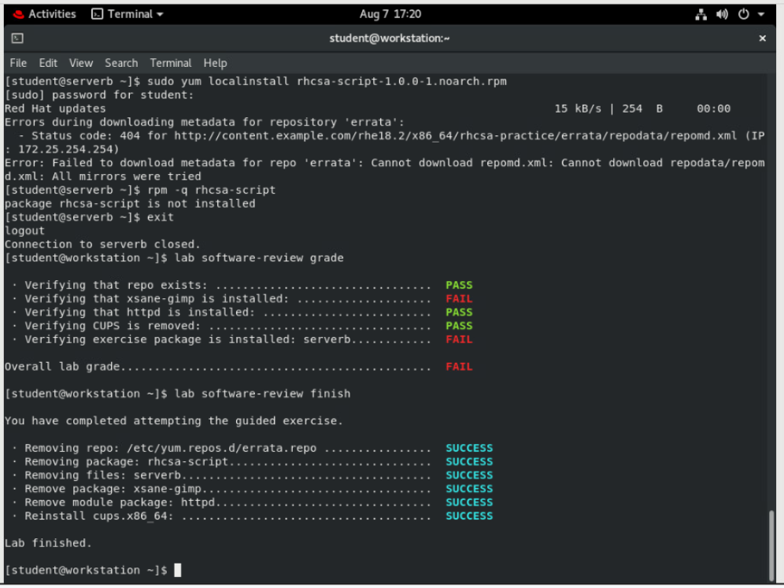

This concludes the lab.